NOMBRE DE LA MATERIA

Fundamentos de Redes

NOMBRE DEL DOCENTE

Rafael Preciado Gutiérrez

NOMBRE DEL TRABAJO

Actividad 4

NOMBRE DEL ALUMNO

Alejandro Guevara de Luna

UNIDAD

2

FECHA Y LUGAR

2 de octubre del 2022

Instituto Tecnológico de Pabellón de Arteaga

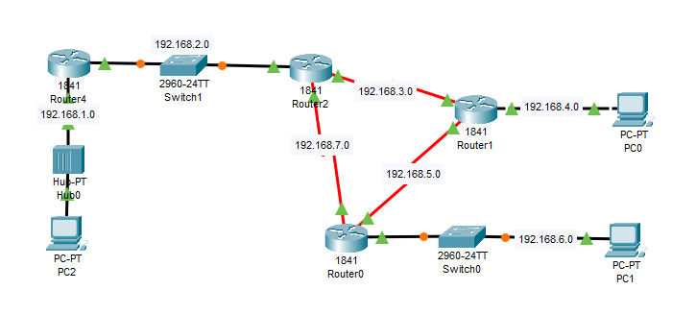

|  |  |  |  |  |
| --- | --- | --- | --- | --- |
| Dispositivo | Puerto | IPv4 | Mascara | Gateway |
| Router 1 | S 0/0 | 192.168.5.1 | 255.255.255.0 | NA |
| S 0/1 | 192.168.7.1 | 255.255.255.0 | NA |
| Fa 0/0 | 192.168.6.1 | 255.255.255.0 | NA |
| Router 2 | S 0/0 | 192.168.5.2 | 255.255.255.0 | NA |
| S 0/1 | 192.168.3.1 | 255.255.255.0 | NA |
| Fa 0/0 | 192.168.4.1 | 255.255.255.0 | NA |
| Router 3 | S 0/0 | 192.168.7.1 | 255.255.255.0 | NA |
| S 0/1 | 192.168.3.2 | 255.255.255.0 | NA |
| Fa 0/0 | 192.168.2.1 | 255.255.255.0 | NA |
| Router 4 | Fa 0/0 | 192.168.2.2 | 255.255.255.0 | NA |
| Fa 0/1 | 192.168.1.1 | 255.255.255.0 | NA |
| PC0 | Fa 0/0 | 192.168.4.2 | 255.255.255.0 | 192.168.4.1 |
| PC1 | Fa 0/0 | 192.168.6.2 | 255.255.255.0 | 192.168.6.1 |
| PC2 | Fa 0/0 | 192.168.1.2 | 255.255.255.0 | 192.168.1.1 |